The Enlightenment in Europe
Packet #1

- The Enlightenment (1600s -1700s)

  - a new intellectual movement

    - stressed ______________________________________________
    - stressed _________________________________________________________________

  - Known as _____________________________________________

  - Reached its height in the mid-1700s

    - ________________________________________________________________
________________________________________________________________
- Two Views of Government

  - Enlightenment ___________________________________________ put forth by ___________
____________________________________________of the 1600s
    - ___________________________
    - ___________________________

      - Both men experienced political turmoil of England early in the 17th century, but came to different conclusions about government and human nature

  - Hobbe’s “Social Contract”

    - Hobbes published Leviathan in 1651
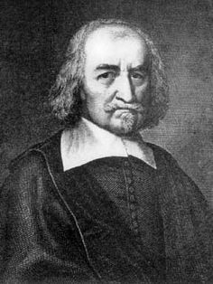

Thomas Hobbes
      - _________________________________________________________________
_________________________________________________________________
      - _________________________________________________________________
_________________________________________________________________
Hobbes argued that to escape such a bleak life, people had to hand over their
rights to a strong ruler. In exchange, they gained law and order. Hobbes called this agreement by which people created a government the social contract.

    - Idea of the social contract

      - _________________________________________________________________
      - _________________________________________________________________
      - _________________________________________________________________
_________________________________________________________________
"The condition of man... is a condition of war of everyone against everyone."

  - Locke’s “Natural Rights” of Man

    - John Locke - ________________________________

      - Held a more positive view of human nature than that of Hobbes

        - ____________________________________________________________
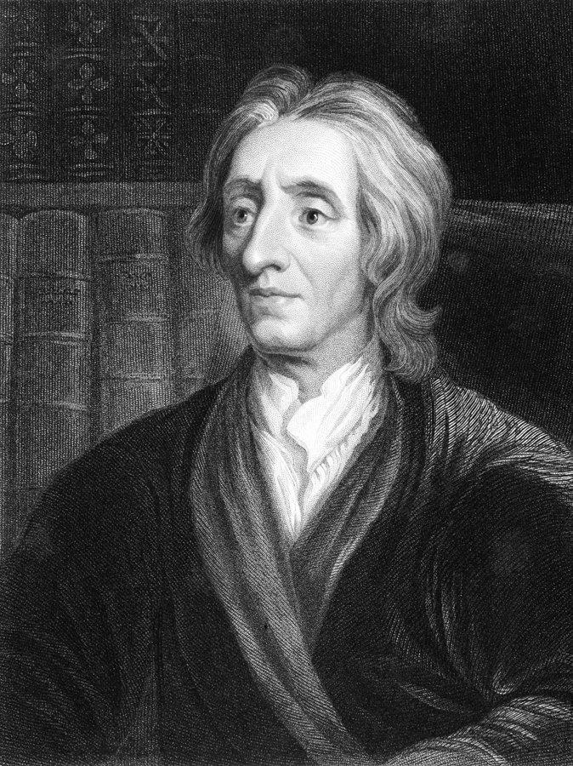
John Locke
____________________________________________________________
        - ____________________________________________________________
____________________________________________________________
      - Locke asserted that “all people are born free and equal”
        - Three Natural Rights

          - _______________________________
          - _______________________________
          - _______________________________
        - Purpose of Government to protect the three natural rights. If a government fails to do so, citizens have a right to overthrow it.

      - Locke’s theory had a deep influence on modern political thinking. ____________
__________________________________________________________________
__________________________________________________________________
__________________________________________________________________ The ideas of government by popular consent and the right to rebel against unjust rulers helped inspire struggles for liberty in Europe and the Americas.

"Every man has a property in his own person. This nobody has a right to, but himself."

- Philosophes (French for philosophers)
  - Held the voice at the height of the Enlightenment

    - France, 1770s: Paris became the meeting place for people who
    - wanted to discuss politics and ideas.

    - Referred to as ______________________________ of this period
    - Believed ____________________________________________________________
(just as Isaac Newton had applied reason to science)

  - Five Core Beliefs of the Philosophes

    - 1. _________________________________

      - Truth could be discovered through reason

    - 2. _________________________________

      - Believed what is natural was good and reasonable

    - 3. _________________________________

      - Rejected medieval notion that people should find joy in the hereafter and urged people to seek well-being on earth

    - 4. _________________________________

      - Stressed that society and mankind could improve

    - 5. _________________________________

      - Called for liberties that the English had won in their “Glorious Revolution” and Bill of Rights
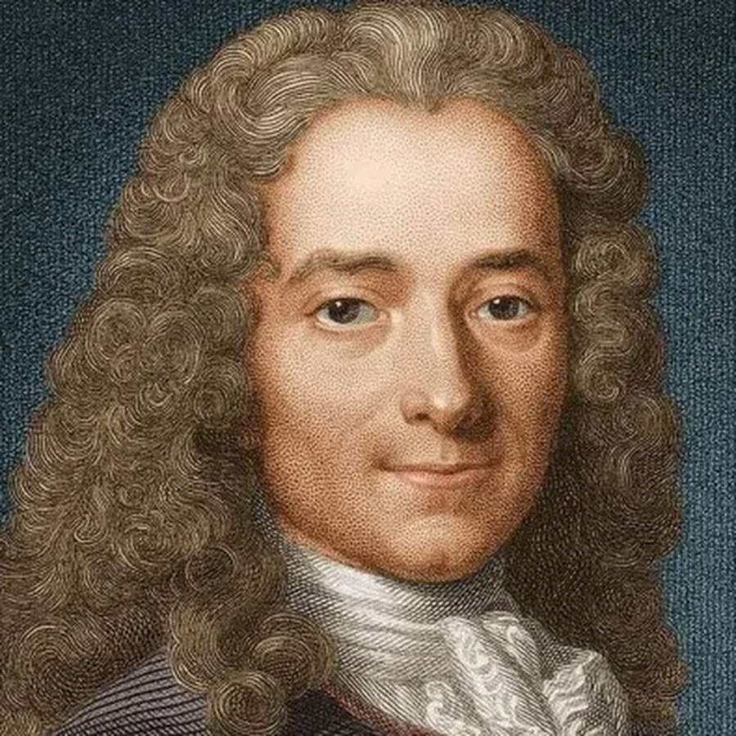
Voltaire

- Three Great Philosophes

  - __________________________________

    - One of the most brilliant of the philosophes
    - Published over 70 books
    - Used satire
      - ________________________________________________________________
________________________________________________________________

    - Sent to prison twice for his words

      - BUT never stopped fighting for ____________________, ___________________, ____________________________________and_______________________________________________________.
      - He used his quill pen as if it were a deadly weapon in a thinker’s war against humanity’s worst enemies—intolerance, prejudice, and superstition. He summed up his staunch defense of liberty in one of his most famous quotes: “I do not agree with a word you say but will defend to the death your right to say it.”

  - ____________________________________

    - Devoted to the study of political liberty
    - “____________________________________________”
      - Believed that Britain was the best-governed and most politically balanced country
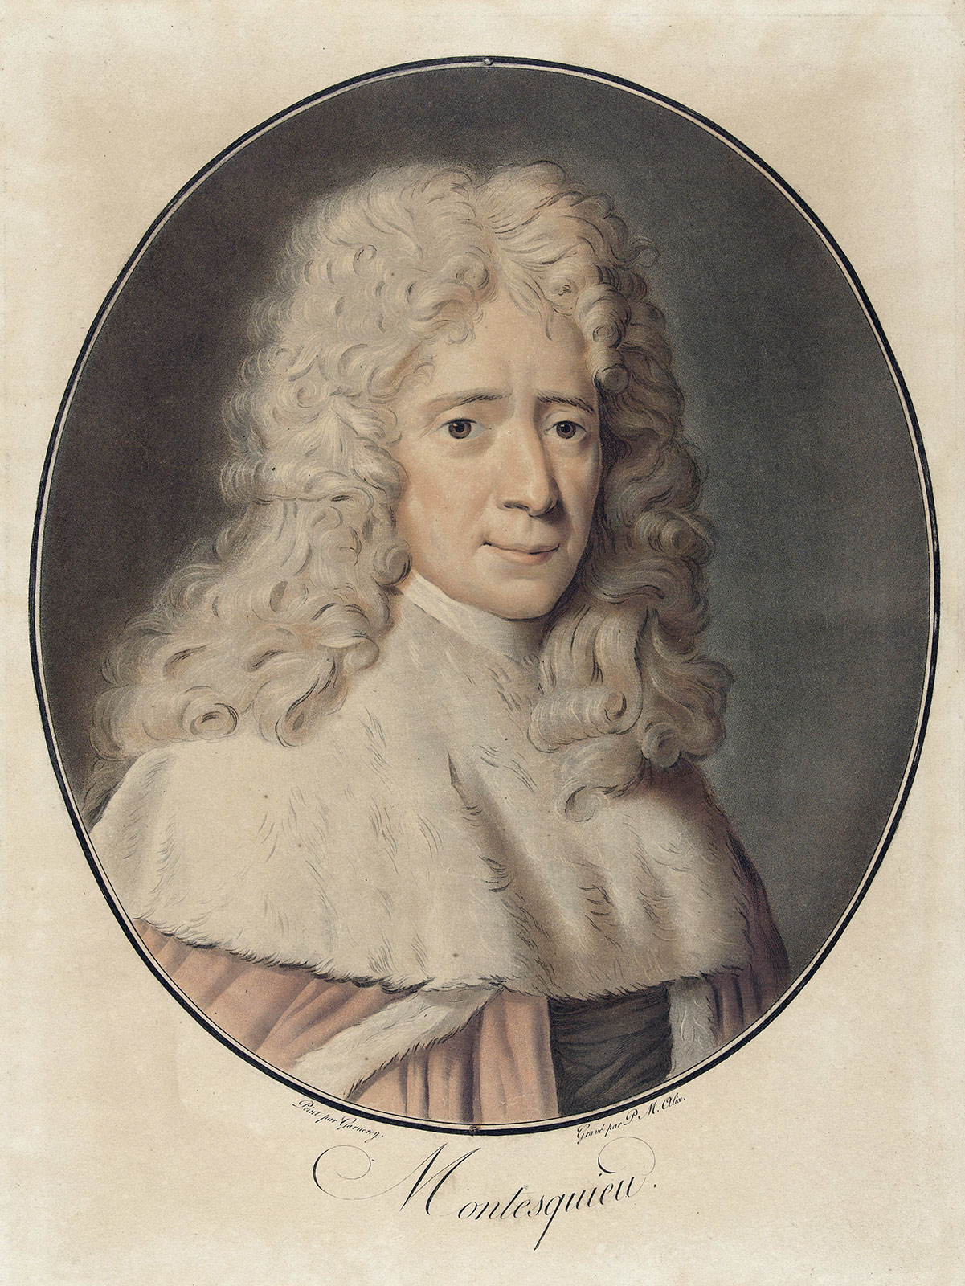
Montesquieu

        - Britain, he believed modeled the idea of “separation of powers”

          - King and ministers – _________________________________

          - Parliament – _______________________________________

          - Judges of the English courts – _____________________________

    - Montesquieu actually oversimplified the English government, but his ideas became part
of a book he wrote, __________________________________________________ (1748)

      - “Power” he wrote “should be a check to power.”
        - This idea becomes known as the “_______________________________” later adopted by the American colonies in the constitution. (Montesquieu’s book was admired by political leaders in the British colonies of North America. His ideas about separation of powers and checks and balances became the basis for the United States Constitution.)

  - _______________________________________

    - ________________________________________________________________
    - Strongly disagreed with other Enlightenment thinkers about many matters.
Most philosophes believed that reason, science, and art would improve life for all people. Rousseau, however, ______________________________________________
______________________________________________________. “Man is born free, and every-where he is in chains,” he wrote.

    - Believed the only good government was one that was freely formed by the people and guided by the “_________________________________” of society
    - Best form of government was a ______________________________________
    - Published the Social Contract in 1762

      - Different from Hobbes’ view of a social contract
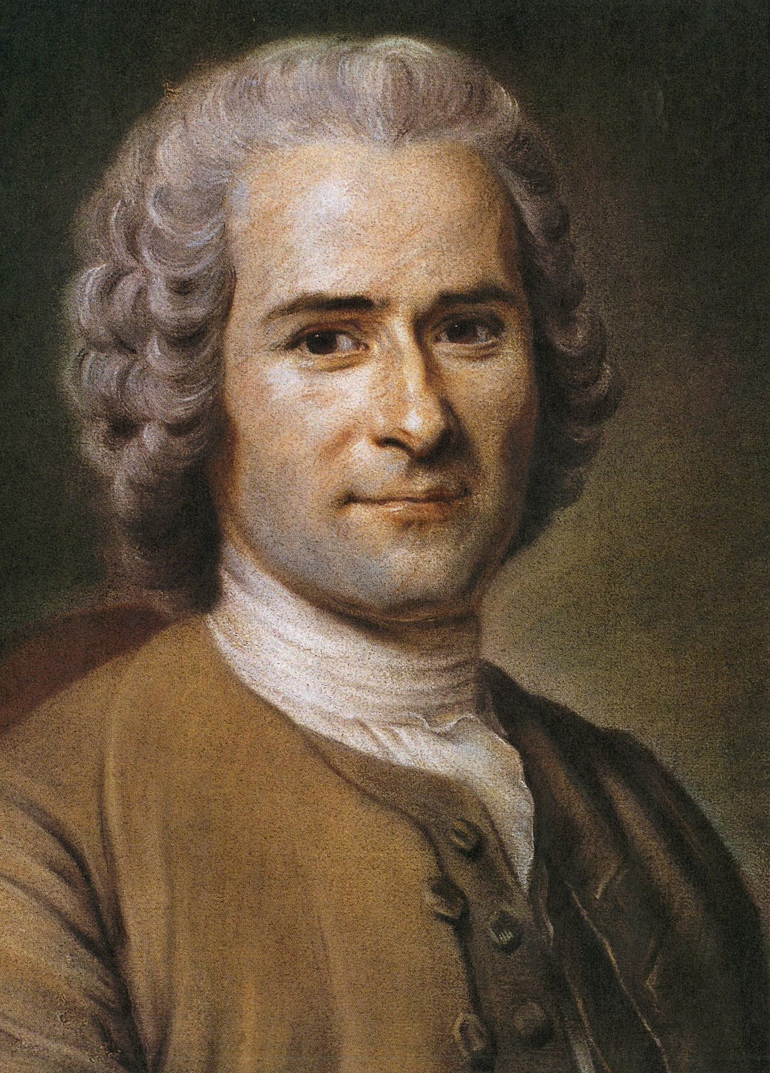
Rousseau

        - Hobbes – ___________________________________________________
___________________________________________________

        - Rousseau – _________________________________________________
_________________________________________________
      - He argued that all people were equal and that titles of nobility should be abolished. Rousseau’s ideas inspired many of the leaders of the French Revolution who overthrew the monarchy in 1789.

- Legacy of the Enlightenment

  - ___________________________________________
    - Although the philosophes were not active revolutionaries, they inspired revolution.
      - American Revolution
      - French Revolution
  - Three Long-Term Effects that Shaped Western Civilization

    - 1. ____________________________________________

      - Scientific revolution opened the door for growth of knowledge and discoveries

    - 2. ____________________________________________

      - People began to question the teachings and religious beliefs of the church

    - 3. ____________________________________________

      - As people turned from the church and royalty, they looked to themselves for answers.
      - Philosophes encouraged people to use their own ability to reason in order to judge right and wrong.

Major Ideas of Enlightenment

Idea | Thinker | Impact

